**1)**

**Download and install 按键精灵 2014.05.17762 正式版 (qm2014chs.exe)**

(<http://soft.onlinedown.net/soft/104738.htm>)

**2)**

Start “按键精灵” and create 2 Buttons in one new form:

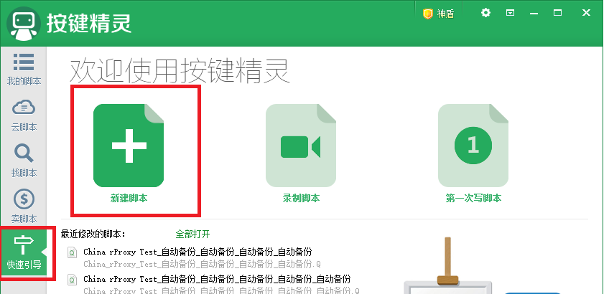

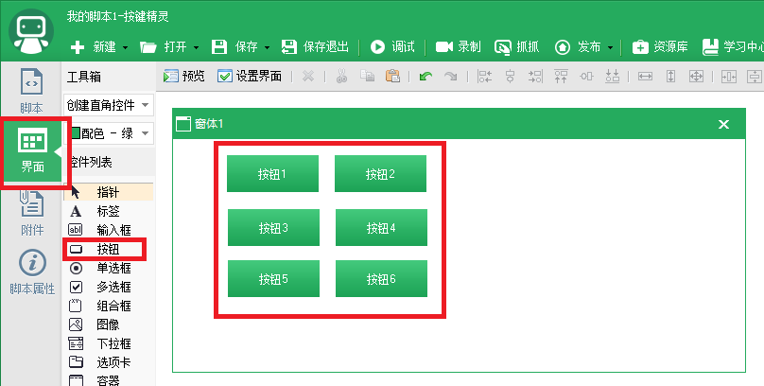

**3)**

Copy below script for “按钮1” - “按钮6”:



**4)**

Change the caption of “按钮1”, “按钮2” and “按钮3”:

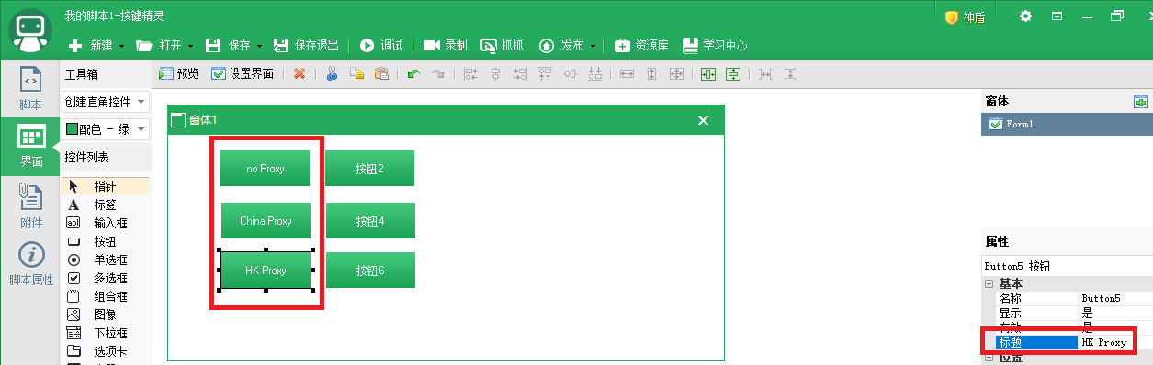

**5)**

Use “抓抓” to get 3 window handlers of browsers and update Hwnd**3**, Hwnd**4** and Hwnd**5** for the script of “**Button1**” and “**Button2**”:



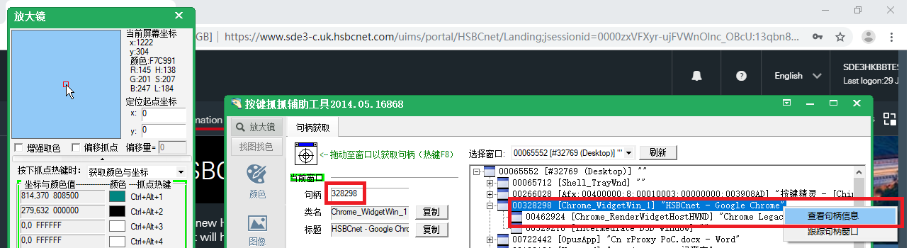

**6)**

Use “抓抓” to get 3 check point positions on browsers and update Window**3_X**, Window**3_Y**, Window**4_X**, Window**4_Y**, Window**5_X**, Window**5_Y** for the script of “**Button1**” and “**Button2**”:

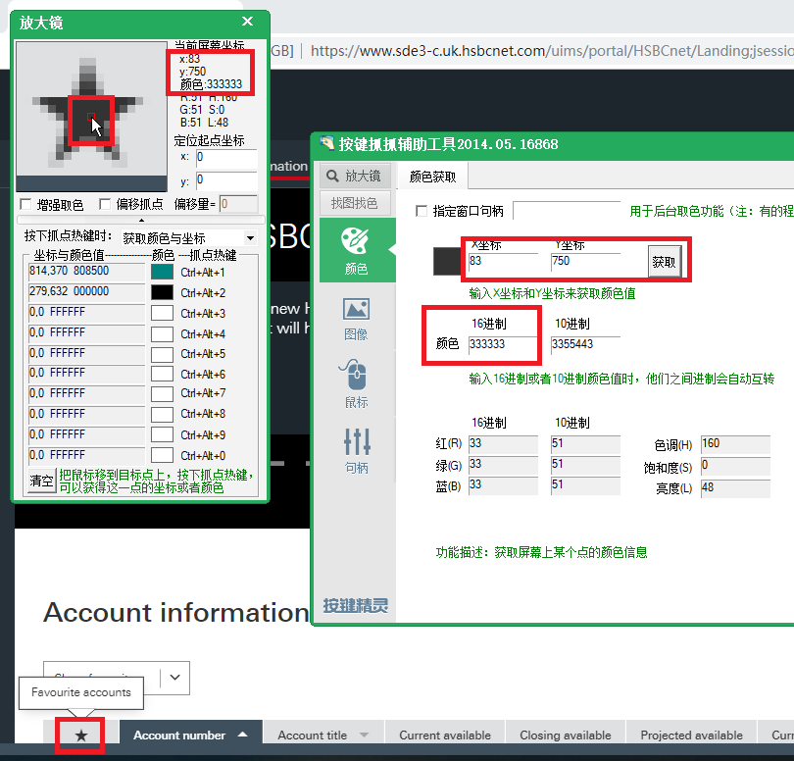

**7)**

Use “**按钮2**”, “**按钮4**”, “**按钮6**” to test the window handlers and check positions respectively.

Use “**no Proxy**”, “**China Proxy**”, “**HK Proxy**” to start the 10 cases testing respectively.

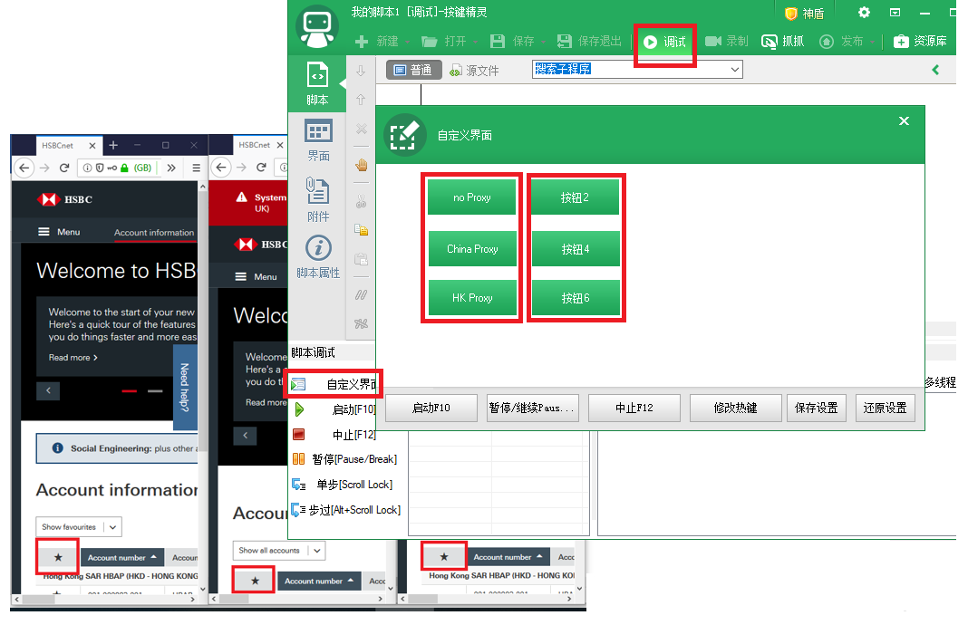

**8)**

Test related info:

**URL**:

<https://www.sde3-c.uk.hsbcnet.com/uims> (**no Proxy**)

<https://www.online-banking-hk-preprod.business.hsbc.com.cn/uims/> (**China Proxy**)

<https://netpoc.p2g.netd2.hsbc.com.hk/uims/> (hkg1vl0070 Pr0tecthkg1vl0070) (**HK Proxy**)

**ID**:

SDE3SGHBAPPOTHER02 (for **ShangHai**)

SDE3SGHBAPPOTHER01 (For **BeiJing**)

SDE3HKBBTEST1 (For **Xi’An**)

**Memorable question and password**

testing1

fstffssl

**Webex**:

<https://hsbc.webex.com/join/pr717023925>

**Tel**: 8620-38586839 Kevin Xie)

**Mobile**: 86-13650738842